**The Effects of Inflammatory Bowel Disease on Brain Microstructure as Quantified Through Diffusion-Weighted MRI**

Ajay Shenoy

April 29, 2024

**Abstract**

Inflammatory Bowel Disease (IBD) encompasses a group of disorders characterized by chronic inflammation of the gastrointestinal tract. Ulcerative colitis and Crohn’s disease are examples of IBD that affect millions globally. IBDs main impact is inflammation of the digestive tract, but IBD also leads to neurological complications which may be due to alterations of the central nervous system (CNS), secondary to the inflammation in the digestive tract. Our research goal is to find out if and how IBD causes alterations in the CNS that could lead to psychiatric problems. With an understanding of how IBD causes psychiatric problems, we can broaden IBD treatment to treat psychological and physical symptoms, and better adapt treatment to each unique patient.

To explore the neurological impact of IBD we utilized a rodent model of IBD induced by dextran sodium sulfate (DSS). Using diffusion MRI techniques like diffusion tensor imaging (DTI) and neurite orientation and dispersion index (NODDI) imaging, we measured changes in brain microstructure in several psychiatrically relevant brain regions. Our analysis assessed differences between DSS-induced colitis mice and control mice. These findings show IBD-related brain changes, which allows us to gain insights into potential mechanisms as to how associated neuropsychiatric disorders are caused in IBD patients. The findings showed us that IBD alters the brain structure, more so in females than males, which may explain why females experience more IBD-induced anxiety and depression than males, as females uniquely have changes in the amygdala, a structure important in emotional processing and implicated in many neuropsychiatric disorders.

**Introduction**

Inflammatory Bowel disease (IBD) encompasses various disorders characterized by chronic inflammation of the gastrointestinal (GI) tract. The causes of the most common IBD, Crohn’s disease and ulcerative colitis, are unknown but occur through autoimmune pathways. Crohn’s disease involves the swelling of the digestive tract, leading to abdominal pain, diarrhea, fatigue, and malnutrition. Ulcerative colitis causes inflammation and ulcers in the digestive tract and may be aggravated by stress and diet. Both affect roughly 300,000 - 400,000 people in the United States each year and around 7.5 million people worldwide.

IBD impacts not just the gastrointestinal tract but can affect the Central Nervous System (CNS) through the inflammation of neurons. IBD-associated inflammation triggers the release of cytokines, chemokines, and other signaling molecules into the bloodstream, which plays an important role in neurological pathogenesis by heightening neurodegenerative processes and disrupting neuronal function. A dysregulated immune response can compromise the blood-brain barrier, allowing inflammatory mediators to infiltrate the CNS. CNS inflammation can activate microglia, specific immune cells in the brain, which release additional cytokines and further contribute to oxidative stress, synaptic dysfunction, and neurodegeneration.

Disruption of communication between the gut and brain, or the gut-brain axis, can further increase neurological complications associated with Inflammatory Bowel disorder. Emerging evidence suggests that IBD-associated dysbiosis, or changes in the gut microbiota, may influence CNS function and behavior via the gut-brain axis. Associated neurological conditions include Melkersson-Rosenthal syndrome, optic neuritis, and sensorineural hearing loss. Patients with IBD often experience mood disorders such as anxiety and depression, which are thought to arise from inflammatory processes, alterations in neurotransmitter systems, and psychosocial factors. However, neurological complications associated with IBD that extend beyond these common symptoms are understudied. Investigation into cognitive dysfunction, sleep disturbances, and autonomic nervous system dysfunction in patients with IBD can provide valuable insights into the broader impact of this condition on neurological health.

Studying Inflammatory Bowel disease’s impact on brain microstructure provides an avenue to explore the impacts of IBD beyond the gut, which is relatively understudied despite growing evidence suggesting a correlation between IBD and brain function. The brain microstructure is the composition of the brain at the microscopic level, encompassing the arrangement of cells like neurons and glial cells in the brain. Changes in brain microstructure can inform our understanding of the relationship between systemic inflammation and neurological outcomes and can provide information on cognitive function, mood regulation, depression, and anxiety. Inflammation of the brain microstructure can cause issues in the function of affected areas of the brain.

Studies show brain connectivity, gray matter volume, and white matter integrity are all affected, highlighting the importance of investigating the association between brain microstructure changes and psychological symptoms in IBD patients. We use multi-compartment diffusion-weighted MR imaging to detect changes in brain microstructure by measuring the water diffusion signal in the brain. Water diffusion in the brain is determined by the brain microstructure as the physical elements of the brain microstructure (such as neurons and their axons, glia, and extracellular matrix) restrict and constrain water diffusion. We use two biophysical models to quantify the changes in the brain structure: Diffusion Tensor Imaging (DTI) and neurite orientation dispersion and density index (NODDI) imaging. These methods are biologically sensitive and enable greater tissue specificity in the imaging signal to microstructural changes than typical structural MRI techniques. In particular, we measure the fractional anisotropy (FA) and mean diffusivity (MD) measures from the DTI model which can provide indirect measures of the white matter structure and the neurite density index (NDI) and orientation dispersion index (ODI) from the NODDI model which can detect changes in both white and gray matter microstructure.

By tracking changes in brain microstructure after disease progression, we explore the dynamic nature of IBD-related brain changes that are associated with neuropsychiatric disorders such as depression and anxiety.

**Methods**

We employed a rodent model of the IBD to study brain microstructure. Male and female C57Bl6/J mice, aged between postnatal days 130 and 134, were randomly assigned to either a dextran sodium sulfate (DSS)-induced colitis group or a control group. DSS, an NMR sodium salt, was fed to the experimental groups via water and caused damage to their digestive tracts. Animals were sacrificed and their brains were extracted. Imaged brains were placed in a custom-built holder immersed in Fluorinert (FC-3283, 3M, St. Paul, MN, USA) and imaged with a 4.7-T Agilent MRI system with a 3.5-cm diameter quadrature volume RF coil. Multi-slice, diffusion-weighted, spin echo images were used to acquire 10 non-diffusion weighted images (b = 0 s•mm−2) and 75 diffusion-weighted images (25: b = 800 s•mm−2, 50: b = 2,000 s•mm−2), using non-collinear diffusion-weighting directions. Other imaging parameters: TE/TR = 24.17/2000-ms, FOV = 30 × 30 mm2, matrix = 192 × 192 reconstructed to 256 × 256 for an isotropic voxel size of 0.25-mm over two signal averages. These diffusion images were then processed using diffusion tensor image (DTI) and NODDI, to assess brain microstructure. We measured mean values of fractional anisotropy, mean diffusivity, neurite density, and orientation dispersion in seven regions of interest (ROIs): the amygdala, corpus callosum, frontal association cortex, globus pallidus, hippocampus, internal capsule, and thalamus.

We used independent t-tests to compare mean values of neurite density, orientation dispersion, fractional anisotropy, and mean diffusivity between DSS-induced colitis mice and control mice within each sex group. The independent variables in our study included the ROI (amygdala, corpus callosum, frontal association cortex, globus pallidus, hippocampus, internal capsule, thalamus), sex of the mice (male, female), image type (FA, MD, NDI, ODI), and the treatment condition (DSS or vehicle). The dependent variables were the mean values of fractional anisotropy, mean diffusivity, neurite density, and orientation dispersion measured using DTI and NODDI (Mean Intensity). Changes in mean values between the control and DSS groups indicate the effect of DSS-induced colitis on brain microstructure.

**Results**

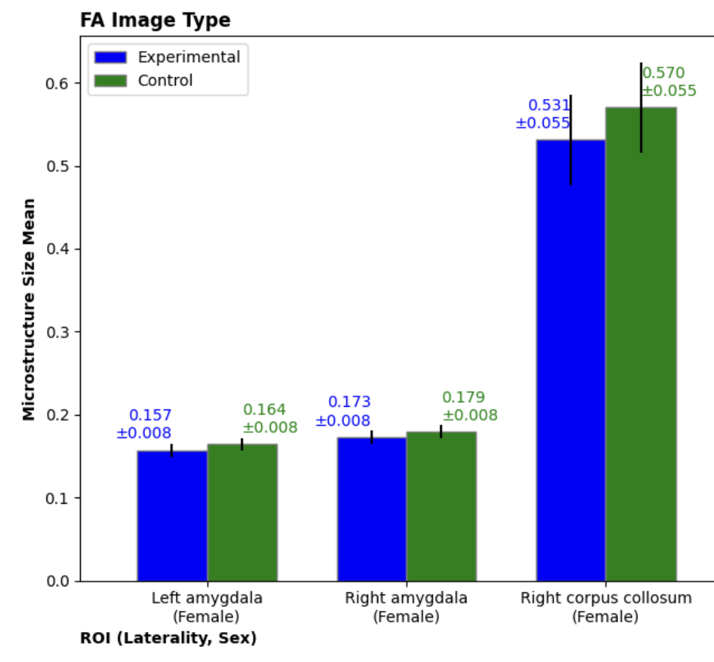

**Figure 1.** Statistically significant differences in the mean FA across the regions of interest for female animals, with standard deviation of 95% confidence intervals.

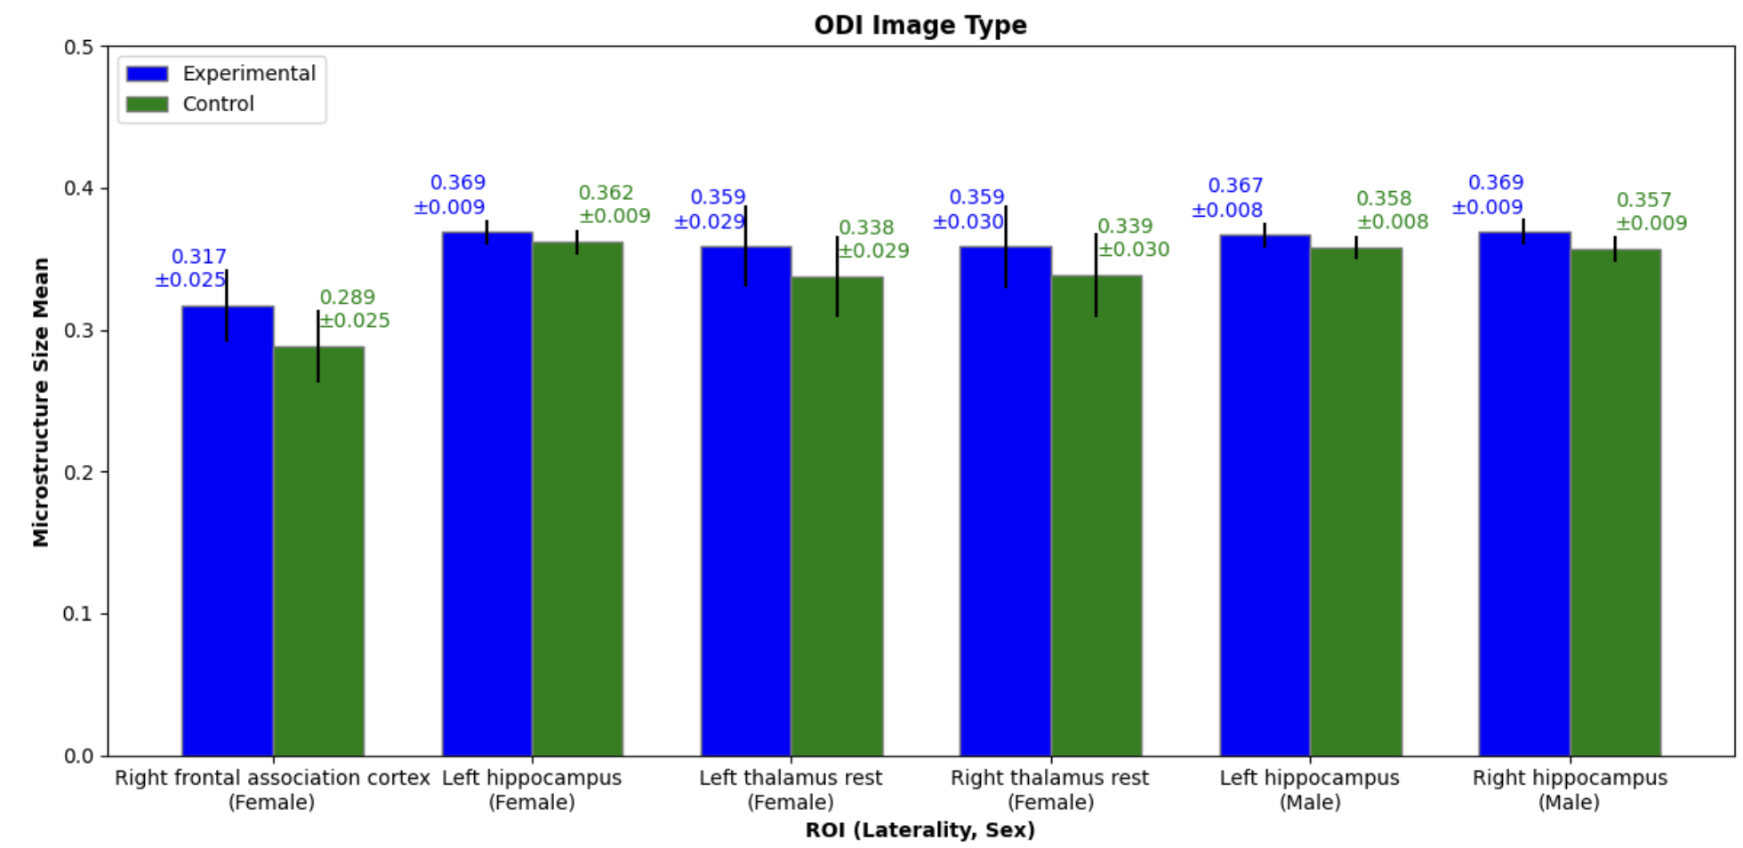

**Figure 2.** Statistically significant differences in the mean ODI across the regions of interest for female and male animals, with standard deviation of 95% confidence intervals.

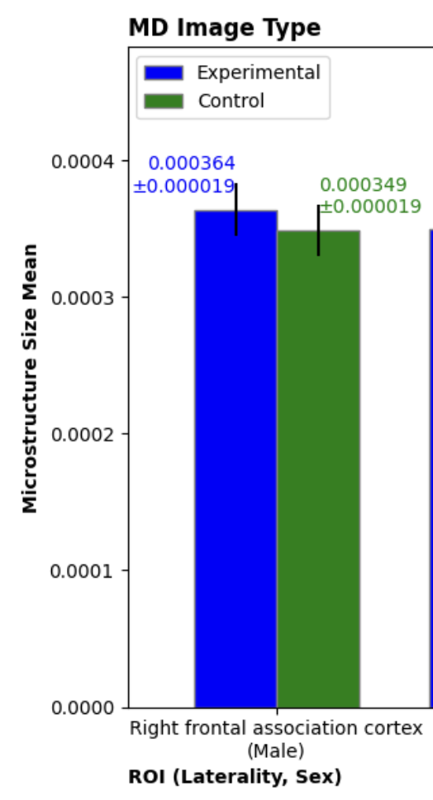

**Figure 3.** Statistically significant differences in the mean MD across the regions of interest for male animals, with standard deviation of 95% confidence intervals.

|  |  |  |  |  |  |  |  |
| --- | --- | --- | --- | --- | --- | --- | --- |
| Sex | ROI | Laterality | Image  Type | Mean Difference | Standard Deviation | P Value | T-Statistic |
| Female | Amygdala | Left | FA | -0.007169 | 0.007711 | 0.046401 | -2.095659 |
| Female | Amygdala | Right | FA | -0.006507 | 0.007965 | 0.059047 | -1.978027 |
| Female | Corpus Callosum | Right | FA | -0.038929 | 0.054680 | 0.043240 | -2.129505 |
| Female | Frontal Association Cortex | Right | ODI | 0.28508 | 0.025433 | 0.016089 | 2.581500 |
| Female | Hippocampus | Left | ODI | 0.006962 | 0.008760 | 0.041266 | 2.151785 |
| Female | Thalamus | Left | ODI | 0.021070 | 0.028615 | 0.041670 | 2.147151 |
| Female | Thalamus | Right | ODI | 0.019935 | 0.029512 | 0.056649 | 1.998497 |
| Male | Hippocampus | Left | ODI | 0.008686 | 0.008362 | 0.021440 | 2.453990 |
| Male | Hippocampus | Right | ODI | 0.011577 | 0.009258 | 0.000606 | 3.921598 |
| Male | Frontal Association Cortex | Right | MD | 0.000015 | 0.000019 | 0.044058 | 2.120539 |

**Table 1.** A summary of the areas of the brain that exhibited statistically significant (p < 0.05) increased mean value from the control to experimental group (inflammation), and its ROI, laterality, image type, Standard Deviation, Mean Difference, P value, and T-test.

Female animals treated with DSS had a significant decrease in FA in the left and right amygdala and the right corpus callosum. Females also had a significant increase in ODI in the right and left thalamus, left hippocampus, and right frontal association cortex. Male animals treated with DSS had a significant increase in ODI in the left and right hippocampus. Males also had a significant increase in MD in the right frontal association cortex. Interestingly, no changes were seen in NDI across the two sexes.

Both males and females had significant changes in diffusion measures in the IBD condition. However, these changes were different between the two sexes. Males saw no significant changes in FA while females saw no significant changes in MD. In ODI males saw changes in the left and right hippocampus while females only saw changes in the left hippocampus. Females observed change in the right frontal association cortex in ODI while males observed change in the right frontal association cortex in MD. Females saw changes in their right and left thalamus in ODI and their left and right amygdala in FA, but males did not see changes in these regions (thalamus and amygdala) in any image type. Females had significantly more changes, with seven, in comparison to males, with three.

**Discussion**

Although not proven by our tests, we hypothesize that the difference in microstructure from control to experimental may be due to neuroinflammation, secondary to the inflammatory state that the DSS animals exhibit. Studies over recent years have shown that neuroinflammation due to the activation of macrophages and microglia are important in the pathogenesis of mental diseases and has seen to lead to a high risk for depression and anxiety disorders. This inflammation affects neurotransmitters in the brain and the neural circuitry of emotion. The neurotransmitters in the brain, such as serotonin, become downregulated, and the quantity of the neurotransmitters in the brain decrease, which is in the pathology of depression. The circuitry of emotion is the brain regions which are responsible for emotion regulation and responses in humans, which are the amygdala, frontal cortex, and other areas relaying signals between these regions. Inflammation in these regions causes the regions to send out an excessive number of responses, causing emotional instability.

In our study, we see microstructural changes in the amygdala and hippocampus only in females. which may be a reason for the difference in IBD psychological prognosis seen in human patients between the sexes. The role of the amygdala in the brain is to regulate emotions and memory, and associations with the brain’s reward system and to process anxiety, while the role of the hippocampus is to receive information from the cerebral cortex. We have seen from studies of IBD that females have increased anxiety and depression severity and rates, and a worsened sleep quality and quality of life. This leads us to question if the inflammation in the amygdala and hippocampus can be correlated to this.

Regularly, the amygdala maintains a resting state where amygdala activity is mostly inhibited. to the inhibition, the amygdala avoids activation by small external stimuli and does not produce emotional behavioral responses. Contrastingly, in pathological conditions like inflammation, the inhibitory state of the amygdala is removed, and the amygdala responds to all the small stimuli it encounters. In this inflamed state, the amygdala produces many inappropriate emotional behavioral responses which leads to emotional instability, spikes, and extreme mood swings and experiences, which all align with symptoms of anxiety and depression. In addition, in this hyperactivation of the amygdala, the amygdala also produced more pro-inflammatory cytokines, which contributes to the amygdala inflammation and strengthens the inflammatory cycle. In literature this hyperactivation of the amygdala is known to cause neuropsychiatric disorders and specifically is a fundamental cause of anxiety and depression.

Similarly to the amygdala, the hippocampus also plays a role in causing neurological problems. The hippocampus has the same inflammatory cycle as the amygdala, which increases anxiety and depression. Unique to the hippocampus, elevated levels of these pro-inflammatory cytokines can disrupt the function of the hippocampus by impairing neurogenesis, synaptic plasticity, and neurotransmitter regulation. These disruptions alter the balance of neural circuits that are involved in stress response and emotion regulation, which in totality contribute to creating anxiety-like and depressive-like symptoms. This dysregulation perpetuates a cycle of chronic stress and mood disturbances that are characteristic of anxiety and depression.

There are many contributing factors to this discrepancy that could range from sex hormones, immune response, environmental factors, intestinal microecology, and gut biome health. The primary female sex hormones are progesterone and estrogen, meanwhile, the primary male sex hormone is testosterone. Sex hormones, mainly estrogens, and critical phases such as puberty and menopause, induce epigenetic changes that can contribute to a different pathogenesis and epidemiology of IBD. Additionally, sex hormones are important for the regulation of the regulation of the gut microbiome, gut-brain axis, and the blood-brain barrier, so instability in these hormones may cause issues in these regions that are causes for IBD inflammation and IBD neuroinflammation. In addition to these, one leading reason for these differences across genders may be caused by genetic polymorphism, which is a difference in gene expression across genders. In terms of genetic differences, there are multiple loci that affect IBD pathogenesis on the X chromosome, and since females have an XX chromosome pairing and males have an XY chromosome pairing they are more likely to have these loci, which can increase chances of IBDs or neuropsychological symptoms from IBD. A difference in immune response is one theory that explains why IBD is different in males and females. Immune responses are involved in controlling the pathogenesis of IBD, and an abnormal immune response will lead to a different IBD pathogenesis (disease progression) than a normal immune response would. Females have fewer T-regulatory cells in the gut lymphoid than males, which means that they typically have a weaker immune response.

In total, all of these differences may serve to explain why IBD’s psychological prognosis differs between males and females, and why additional research has suggests that females have significantly higher rates of anxiety and depression as well as much stronger anxiety and depression because of IBD in comparison to their male counterparts.Since we find a change in microstructure in the hippocampus in both sexes and the amygdala in only females, we can hypothesize that differences in neuropsychiatric incidence and presentation between males and females may be due to this difference in brain microstructural changes. This also further necessitates studying why IBD causes a significant difference in microstructural changes in females and males, and more specifically why females have more microstructural changes than males.

However, in human cases of IBD, alterations outside of the brain may also impact the difference in psychological symptoms between males and females. Females also have been seen to have more sleep disruption and a worse quality of life from IBD in comparison to their male counterparts. 9% of males exhibited one of the neurological issues mentioned above (anxiety, depression, sleep disturbance, poor quality of life) in comparison to 14% of females experiencing. Outside of microstructural changes some contributing factors to this trend may be hematochezia (rectal bleeding) and female hesitancy to use drugs. In terms of IBD prognosis females and males also experience differences. Females are more commonly in the active stage, which has the most psychological effects while males are not, and therefore experience more symptoms which leads to a higher number of complications, drugs needed, and surgical treatments in comparison to females.

This study is not without limitations. There is a possibility for human and machine error in the process of gathering the imaging data and writing code to calculate the data, but overall, it is very, very unlikely for there to be any error in our results. The overall hypothesized inflammation mechanism of IBD in the brain’s microstructure is a cause of depression and anxiety, which affects both sexes. Additionally, inflammation of the hippocampus and the amygdala causes anxiety and depression due to the functions of these structures in the brain.

These findings have the potential to greatly help with the treatment of those with IBD. Currently, the physical effects of IBD are treated with anti-inflammatory medication, antibiotics, biologics, steroids, and immune system modulators. Additionally, the psychological effects of IBD are treated with cognitive behavioral therapy and medications. Cognitive behavioral therapy reduces the mental symptoms caused by IBD-induced anxiety and depression. CBT is currently significantly helpful in reducing the mental symptoms of IBD-induced anxiety and depression and is the most effective method of addressing this. Overall, there are methods of treating the physical and psychological symptoms and problems that are caused by IBD, but we should monitor if these treatments work differently in females and males and specifically try to correlate how treatment response may affect both psychological symptoms and brain microstructural changes.

References

Abraham, C., & Cho, J. H. (2009). Inflammatory bowel disease. New England Journal of Medicine, 361(21), 2066–2078. https://doi.org/10.1056/nejmra0804647

Annotation: This review article discusses the pathophysiology, clinical manifestations, and treatment of inflammatory bowel disease (IBD), providing insights into the complexities of the disorder.

Bartocci B, Dal Buono A, Gabbiadini R, Busacca A, Quadarella A, Repici A, Mencaglia E, Gasparini L, Armuzzi A. Mental Illnesses in Inflammatory Bowel Diseases: mens sana in corpore sano. Medicina. 2023; 59(4):682. https://doi.org/10.3390/medicina59040682

Annotation: This article explores the relationship between mental health disorders and inflammatory bowel diseases (IBD), emphasizing the importance of addressing both physical and psychological aspects of patient care.

Brain anatomy and how the brain works. Johns Hopkins Medicine. (2021, July 14). https://www.hopkinsmedicine.org/health/conditions-and-diseases/anatomy-of-the-brain

Annotation: This article provides an overview of brain anatomy and function, the composition of the central nervous system, main brain regions, deeper structures, protective coverings, blood supply, and cranial nerves, while also offering insights into the complexity of brain function and its role in regulating various bodily processes.

Campbell S, Macqueen G. The role of the hippocampus in the pathophysiology of major depression. J Psychiatry Neurosci. 2004 Nov;29(6):417-26. PMID: 15644983; PMCID: PMC524959.

Annotation: This paper delves into the hippocampus's involvement in major depressive disorder, exploring how elevated glucocorticoid levels may disrupt neurogenesis and neuronal structure, leading to memory deficits, and discusses the potential impact of antidepressant medications on hippocampal integrity, urging further research to understand their role in clinical outcomes.

Chassaing B, Aitken JD, Malleshappa M, Vijay-Kumar M. Dextran sulfate sodium (DSS)-induced colitis in mice. Curr Protoc Immunol. 2014 Feb 4;104:15.25.1-15.25.14. doi: 10.1002/0471142735.im1525s104. PMID: 24510619; PMCID: PMC3980572.

Annotation: This protocol describes the experimental induction of colitis in mice using dextran sulfate sodium (DSS), providing a standardized approach for studying inflammatory bowel disease (IBD) in preclinical models.

Data Used In the Paper: DataFrame

Annotation: This is the dataframe showing all of the independent and dependent variables in one data sheet, the figures and conclusions were made using this data.

Diffusion tensor imaging. Diffusion Tensor Imaging - an overview | ScienceDirect Topics. (n.d.). <https://www.sciencedirect.com/topics/medicine-and-dentistry/diffusion-tensor-imaging#:~:text=Diffusion%20tensor%20imaging%20(DTI)%20is%20an%20MRI%20technique%20that%20measures>

Annotation: This source discusses the application of Diffusion Tensor Imaging (DTI) in various neurological conditions such as epilepsy, traumatic brain injury, gliomas, and lupus, exploring its potential in identifying lesions, characterizing tissue microstructure, and aiding in treatment planning.

Depression and anxiety. Crohn’s & Colitis Foundation. (n.d.). <https://www.crohnscolitisfoundation.org/patientsandcaregivers/mental-health/depression-anxiety#:~:text=While%20it%20can%20take%20time,treatment%20for%20depression%20and%20anxiety>

Annotation: This source emphasizes the prevalence of depression and anxiety in individuals with inflammatory bowel disease (IBD) and provides guidance on recognizing symptoms, seeking professional help, and managing these mental health challenges alongside the physical symptoms of IBD.

Goldberg E, Podell K, Lovell M. Lateralization of frontal lobe functions and cognitive novelty. J Neuropsychiatry Clin Neurosci. 1994 Fall;6(4):371-8. doi: 10.1176/jnp.6.4.371. PMID: 7841808.

Annotation: This study examines the lateralization of frontal lobe functions and explains the distinct roles of the two hemispheres in cognitive processing.

Python Code Written for the Research: Python Notebook

Annotation: This Python code was used throughout the research process. This code was used to generate the data frame and extract the data and compile it into a dataframe. It was also used to create the graphs and do the statistical tests.

professional, C. C. medical. (n.d.). Inflammatory bowel disease: Symptoms, treatment & diagnosis. Cleveland Clinic. <https://my.clevelandclinic.org/health/diseases/15587-inflammatory-bowel-disease-overview>

Annotation: This source provides an overview of inflammatory bowel disease (IBD), including its types, symptoms, causes, diagnosis, management, and prevention strategies, emphasizing the chronic nature of the condition and the importance of medical intervention and lifestyle adjustments in managing symptoms and improving quality of life.

Hu P, Lu Y, Pan BX, Zhang WH. New Insights into the Pivotal Role of the Amygdala in Inflammation-Related Depression and Anxiety Disorder. Int J Mol Sci. 2022 Sep 21;23(19):11076. doi: 10.3390/ijms231911076. PMID: 36232376; PMCID: PMC9570160.

Annotation: This source discusses the pivotal role of stress-induced inflammation in the amygdala, a key region for processing emotions, in the pathophysiology of depression and anxiety disorders, highlighting findings from both animal and human studies and proposing future research directions in this field.

Masanetz RK, Winkler J, Winner B, Günther C, Süß P. The Gut–Immune–Brain Axis: An Important Route for Neuropsychiatric Morbidity in Inflammatory Bowel Disease. International Journal of Molecular Sciences. 2022; 23(19):11111. <https://doi.org/10.3390/ijms231911111>

Annotation: This article explores the gut-immune-brain axis and its role in neuropsychiatric morbidity associated with inflammatory bowel disease (IBD), shedding light on the complex interplay between the gastrointestinal and central nervous systems.

Liu C, Zhang J, Chen M, An P, Xiang J, Yu R, Zeng S, Wei S, Deng B, Liu Z, Jiang C, Shi J, Wu K, Dong W. Gender Differences in Psychological Symptoms and Quality of Life in Patients with Inflammatory Bowel Disease in China: A Multicenter Study. J Clin Med. 2023 Feb 23;12(5):1791. doi: 10.3390/jcm12051791. PMID: 36902578; PMCID: PMC10002859.

Annotation: The study examined gender disparities in psychological symptoms, sleep quality, and quality of life among inflammatory bowel disease (IBD) patients in China, revealing higher rates of anxiety, depression, sleep disturbances, and poorer quality of life among females, prompting the construction of a nomogram model to predict quality of life and suggesting the need for tailored interventions to support female patients' mental health

O'Donnell LJ, Westin CF. An introduction to diffusion tensor image analysis. Neurosurg Clin N Am. 2011 Apr;22(2):185-96, viii. doi: 10.1016/j.nec.2010.12.004. PMID: 21435570; PMCID: PMC3163395.

Annotation: An introduction to diffusion tensor image analysis by Lauren J. O’Donnell, PhD, and Carl-Fredrik Westin, PhD, provides a comprehensive overview of diffusion tensor magnetic resonance imaging (DTI), explaining its principles, measurement techniques, interpretation challenges, and applications in various neuroscientific studies and clinical settings, while also discussing recent advances and future directions in the field.

Rustgi SD, Kayal M, Shah SC. Sex-based differences in inflammatory bowel diseases: a review. Therap Adv Gastroenterol. 2020 Apr 28;13:1756284820915043. doi: 10.1177/1756284820915043. PMID: 32523620; PMCID: PMC7236567.

Annotation: The review explores sex-based disparities in inflammatory bowel diseases (IBD), detailing differences in disease onset, phenotype, pathogenesis, therapeutic response, and outcomes, while highlighting the multifactorial nature of these distinctions and the potential roles of genetics, hormones, microbiome, and environmental factors in shaping them.

Singh AP, Jain VS, Yu JJ. Diffusion radiomics for subtyping and clustering in autism spectrum disorder: A preclinical study. Magn Reson Imaging. 2023 Feb;96:116-125. doi: 10.1016/j.mri.2022.12.003. Epub 2022 Dec 7. PMID: 36496097; PMCID: PMC9815912.

Annotation: This preclinical study investigates diffusion radiomics for subtyping and clustering in autism spectrum disorder, demonstrating the utility of diffusion-weighted MRI in characterizing neurobiological features associated with the disorder.

Stowe NA, Singh AP, Barnett BR, et al. Quantitative diffusion imaging and genotype-by-sex interactions in a rat model of Alexander disease. Magn Reson Med. 2024; 91: 1087-1098. doi: 10.1002/mrm.29917

Annotation: This study employs quantitative diffusion imaging to explore genotype-by-sex interactions in a rat model of Alexander disease, showcasing the potential of diffusion MRI in elucidating neurobiological mechanisms underlying neurological disorders.

U.S. Department of Health and Human Services. (n.d.). The human brain: Major structures and functions. National Institutes of Health. https://nida.nih.gov/videos/human-brain-major-structures-functions

Annotation: The article highlights the various parts and regions of the brain and outlines their specific functions while also explaining how the brain regulates actions through nerve impulses and hormone secretion.

Yi SY, Barnett BR, Torres-Velázquez M, Zhang Y, Hurley SA, Rowley PA, Hernando D, Yu JJ. Detecting Microglial Density With Quantitative Multi-Compartment Diffusion MRI. Front Neurosci. 2019 Feb 19;13:81. doi: 10.3389/fnins.2019.00081. PMID: 30837826; PMCID: PMC6389825.

Annotation: This study investigates the detection of microglial density using quantitative multi-compartment diffusion MRI, offering insights into the visualization and quantification of microglial populations in the brain.

Zarbock KR, Han JH, Singh AP, Thomas SP, Bendlin BB, Denu JM, Yu JJ, Rey FE, Ulland TK. Trimethylamine N-Oxide Reduces Neurite Density and Plaque Intensity in a Murine Model of Alzheimer's Disease. J Alzheimers Dis. 2022;90(2):585-597. doi: 10.3233/JAD-220413. PMID: 36155509; PMCID: PMC9881463.

Annotation: This study investigates the effects of trimethylamine N-oxide on neurite density and plaque intensity in a murine model of Alzheimer's disease, providing insights into the potential role of gut microbiota metabolites in neurodegenerative processes.

Zhang H, Schneider T, Wheeler-Kingshott CA, Alexander DC. NODDI: practical in vivo neurite orientation dispersion and density imaging of the human brain. Neuroimage. 2012 Jul 16;61(4):1000-16. doi: 10.1016/j.neuroimage.2012.03.072. Epub 2012 Mar 30. PMID: 22484410.

Annotation: This article introduces NODDI (neurite orientation dispersion and density imaging), an in vivo imaging technique for quantifying neurite microstructure in the human brain, offering valuable insights into neurobiological processes.